When the EMG signal is decomposed, different motor units are identified.

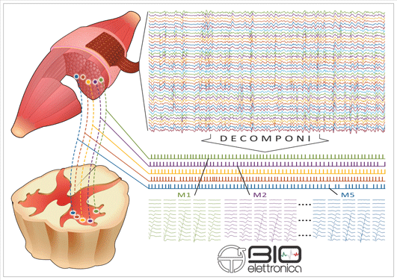

Each channel (in this case 25) corresponds to a single motor unit. Each vertical line corresponds to one firing event. Example of a data file on the next page, in the original software (OT Biolab +). These firing events can be exported as .mat files, .csv files or binary files.

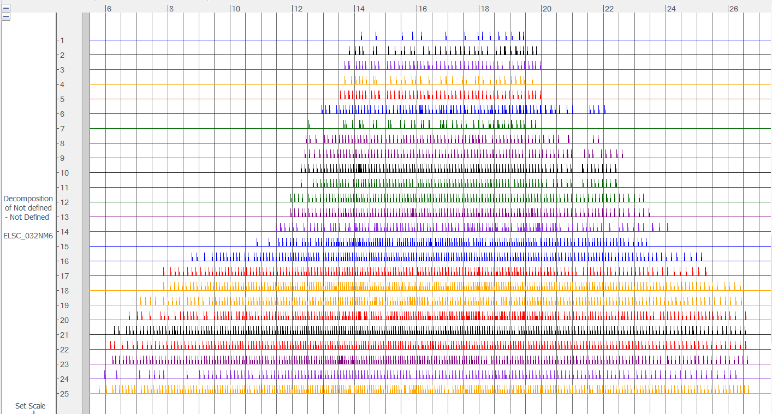

I exported the file above to a .csv file, that I could, for example, open in LabChart:

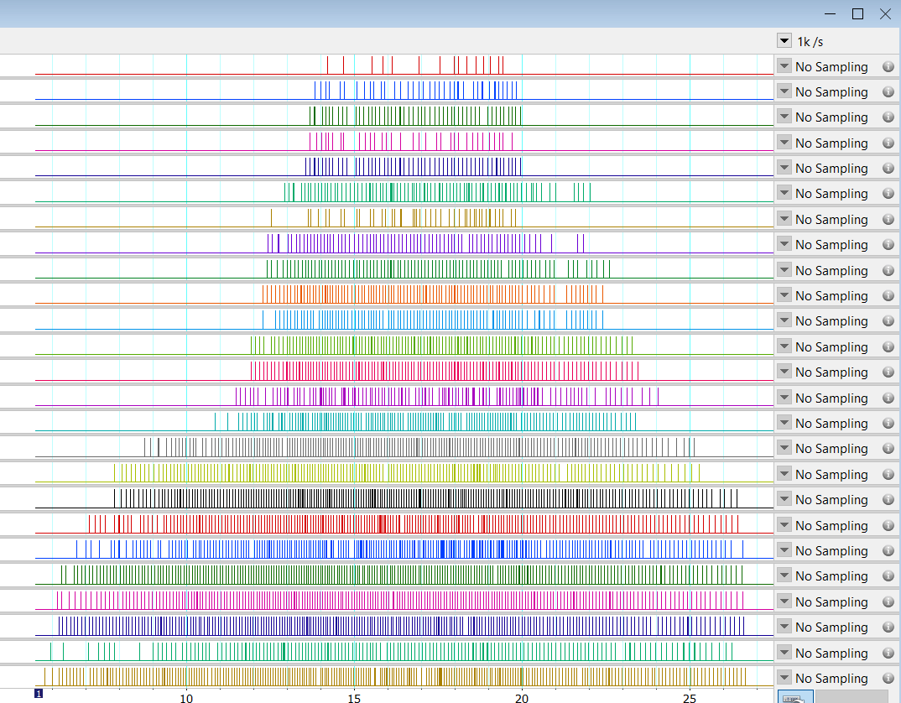

In LabChart I am able to transform the firing events into instantaneous frequency (see below). I would like to then transform this instantaneous frequency to a fifth order polynomial to smooth the firing rate profiles, for subsequent analysis. This is not possible in the LabChart.

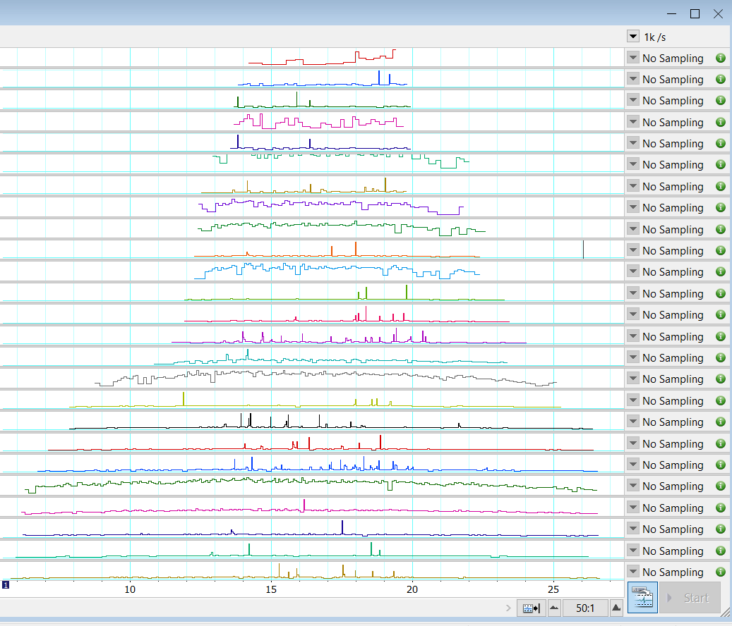

**It would be great to have an automated analysis routine that would:**

* Transform the initial firing events into instantaneous frequency (Hz)
* In each MU, delete initial points and points at the end that is below 4 Hz
* Smooth the instantaneous firing into a fifth order polynomial function
* Plot the polynomial function into a text file (not all the motor units start at the same time so a “0” could be written in the time period when the motor unit is not firing, for example).